PRN: 2019BTECS00037

Name: Onkar Santosh Gavali

Batch: B2

**CNS Lab Assignment 6: Data Encryption Standard**

**Title:** Implementation of Data Encryption Standard

**Aim:**

Part A- To implement DES using Virtual Lab

Part B- To implement DES using C/C++/Java/Python or any other programming language

**Introduction:**

The Data Encryption Standard (DES) is a symmetric-key block cipher published by the National Institute of Standards and Technology (NIST). DES is an implementation of a Feistel Cipher. It uses 16 round Feistel structure. The block size is 64-bit. Though, key length is 64-bit, DES has an effective key length of 56bits, since 8 of the 64 bits of the key are not used by the encryption algorithm.

**Theory:**

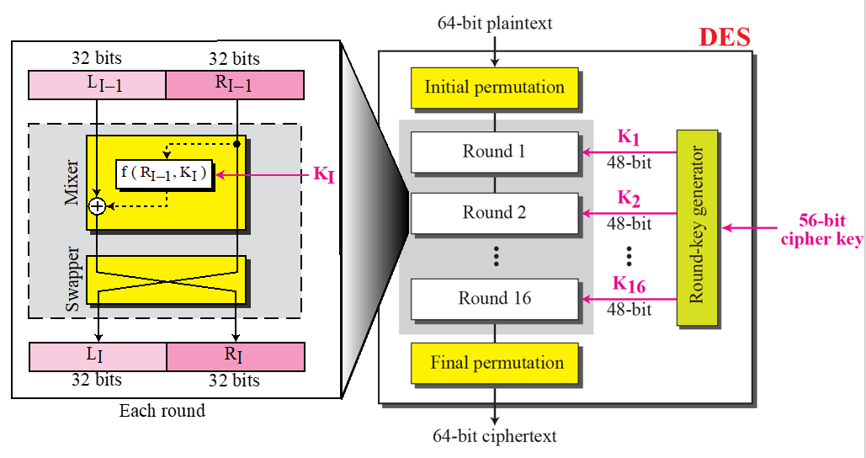

**Procedure:**

**Part A- To implement DES using Virtual Lab**

**Snapshots=>**

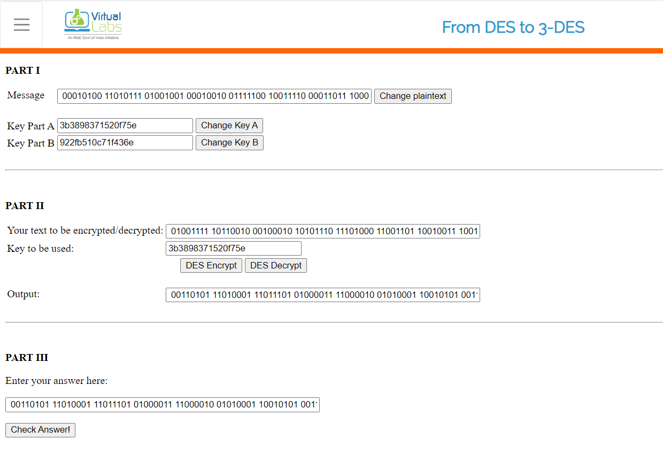

**Part B- To implement DES using C/C++/Java/Python or any other programming language**

**Code=>**

#include <bits/stdc++.h>

using namespace std;

// hexadecimal to binary conversion

string hex2bin(string s)

{

  unordered_map<char, string> mp;

  mp['0'] = "0000";

  mp['1'] = "0001";

  mp['2'] = "0010";

  mp['3'] = "0011";

  mp['4'] = "0100";

  mp['5'] = "0101";

  mp['6'] = "0110";

  mp['7'] = "0111";

  mp['8'] = "1000";

  mp['9'] = "1001";

  mp['A'] = "1010";

  mp['B'] = "1011";

  mp['C'] = "1100";

  mp['D'] = "1101";

  mp['E'] = "1110";

  mp['F'] = "1111";

  string bin = "";

  for (int i = 0; i < s.size(); i++) {

    bin += mp[s[i]];

  }

  return bin;

}

// binary to hexadecimal conversion

string bin2hex(string s)

{

  unordered_map<string, string> mp;

  mp["0000"] = "0";

  mp["0001"] = "1";

  mp["0010"] = "2";

  mp["0011"] = "3";

  mp["0100"] = "4";

  mp["0101"] = "5";

  mp["0110"] = "6";

  mp["0111"] = "7";

  mp["1000"] = "8";

  mp["1001"] = "9";

  mp["1010"] = "A";

  mp["1011"] = "B";

  mp["1100"] = "C";

  mp["1101"] = "D";

  mp["1110"] = "E";

  mp["1111"] = "F";

  string hex = "";

  for (int i = 0; i < s.length(); i += 4) {

    string ch = "";

    ch += s[i];

    ch += s[i + 1];

    ch += s[i + 2];

    ch += s[i + 3];

    hex += mp[ch];

  }

  return hex;

}

string permute(string k, int* arr, int n)

{

  string per = "";

  for (int i = 0; i < n; i++) {

    per += k[arr[i] - 1];

  }

  return per;

}

string shift_left(string k, int shifts)

{

  string s = "";

  for (int i = 0; i < shifts; i++) {

    for (int j = 1; j < 28; j++) {

      s += k[j];

    }

    s += k[0];

    k = s;

    s = "";

  }

  return k;

}

string xor_(string a, string b)

{

  string ans = "";

  for (int i = 0; i < a.size(); i++) {

    if (a[i] == b[i]) {

      ans += "0";

    }

    else {

      ans += "1";

    }

  }

  return ans;

}

string encrypt(string plain_text, vector<string> rkey_bin,

      vector<string> rkey_hex)

{

  // Hexadecimal to binary

  plain_text = hex2bin(plain_text);

  // Initial Permutation Table

  int initial_perm[64]

    = { 58, 50, 42, 34, 26, 18, 10, 2, 60, 52, 44,

      36, 28, 20, 12, 4, 62, 54, 46, 38, 30, 22,

      14, 6, 64, 56, 48, 40, 32, 24, 16, 8, 57,

      49, 41, 33, 25, 17, 9, 1, 59, 51, 43, 35,

      27, 19, 11, 3, 61, 53, 45, 37, 29, 21, 13,

      5, 63, 55, 47, 39, 31, 23, 15, 7 };

  // Initial Permutation

  plain_text = permute(plain_text, initial_perm, 64);

  cout << "After initial permutation: " << bin2hex(plain_text)

    << endl;

  // Splitting

  string left = plain_text.substr(0, 32);

  string right = plain_text.substr(32, 32);

  cout << "After splitting: L0=" << bin2hex(left)

    << " R0=" << bin2hex(right) << endl;

  // Expansion D-box Table

  int exp_d[48]

    = { 32, 1, 2, 3, 4, 5, 4, 5, 6, 7, 8, 9,

      8, 9, 10, 11, 12, 13, 12, 13, 14, 15, 16, 17,

      16, 17, 18, 19, 20, 21, 20, 21, 22, 23, 24, 25,

      24, 25, 26, 27, 28, 29, 28, 29, 30, 31, 32, 1 };

  // S-box Table

  int s[8][4][16] = {

    { 14, 4, 13, 1, 2, 15, 11, 8, 3, 10, 6, 12, 5,

    9, 0, 7, 0, 15, 7, 4, 14, 2, 13, 1, 10, 6,

    12, 11, 9, 5, 3, 8, 4, 1, 14, 8, 13, 6, 2,

    11, 15, 12, 9, 7, 3, 10, 5, 0, 15, 12, 8, 2,

    4, 9, 1, 7, 5, 11, 3, 14, 10, 0, 6, 13 },

    { 15, 1, 8, 14, 6, 11, 3, 4, 9, 7, 2, 13, 12,

    0, 5, 10, 3, 13, 4, 7, 15, 2, 8, 14, 12, 0,

    1, 10, 6, 9, 11, 5, 0, 14, 7, 11, 10, 4, 13,

    1, 5, 8, 12, 6, 9, 3, 2, 15, 13, 8, 10, 1,

    3, 15, 4, 2, 11, 6, 7, 12, 0, 5, 14, 9 },

    { 10, 0, 9, 14, 6, 3, 15, 5, 1, 13, 12,

    7, 11, 4, 2, 8, 13, 7, 0, 9, 3, 4,

    6, 10, 2, 8, 5, 14, 12, 11, 15, 1, 13,

    6, 4, 9, 8, 15, 3, 0, 11, 1, 2, 12,

    5, 10, 14, 7, 1, 10, 13, 0, 6, 9, 8,

    7, 4, 15, 14, 3, 11, 5, 2, 12 },

    { 7, 13, 14, 3, 0, 6, 9, 10, 1, 2, 8, 5, 11,

    12, 4, 15, 13, 8, 11, 5, 6, 15, 0, 3, 4, 7,

    2, 12, 1, 10, 14, 9, 10, 6, 9, 0, 12, 11, 7,

    13, 15, 1, 3, 14, 5, 2, 8, 4, 3, 15, 0, 6,

    10, 1, 13, 8, 9, 4, 5, 11, 12, 7, 2, 14 },

    { 2, 12, 4, 1, 7, 10, 11, 6, 8, 5, 3, 15, 13,

    0, 14, 9, 14, 11, 2, 12, 4, 7, 13, 1, 5, 0,

    15, 10, 3, 9, 8, 6, 4, 2, 1, 11, 10, 13, 7,

    8, 15, 9, 12, 5, 6, 3, 0, 14, 11, 8, 12, 7,

    1, 14, 2, 13, 6, 15, 0, 9, 10, 4, 5, 3 },

    { 12, 1, 10, 15, 9, 2, 6, 8, 0, 13, 3, 4, 14,

    7, 5, 11, 10, 15, 4, 2, 7, 12, 9, 5, 6, 1,

    13, 14, 0, 11, 3, 8, 9, 14, 15, 5, 2, 8, 12,

    3, 7, 0, 4, 10, 1, 13, 11, 6, 4, 3, 2, 12,

    9, 5, 15, 10, 11, 14, 1, 7, 6, 0, 8, 13 },

    { 4, 11, 2, 14, 15, 0, 8, 13, 3, 12, 9, 7, 5,

    10, 6, 1, 13, 0, 11, 7, 4, 9, 1, 10, 14, 3,

    5, 12, 2, 15, 8, 6, 1, 4, 11, 13, 12, 3, 7,

    14, 10, 15, 6, 8, 0, 5, 9, 2, 6, 11, 13, 8,

    1, 4, 10, 7, 9, 5, 0, 15, 14, 2, 3, 12 },

    { 13, 2, 8, 4, 6, 15, 11, 1, 10, 9, 3, 14, 5,

    0, 12, 7, 1, 15, 13, 8, 10, 3, 7, 4, 12, 5,

    6, 11, 0, 14, 9, 2, 7, 11, 4, 1, 9, 12, 14,

    2, 0, 6, 10, 13, 15, 3, 5, 8, 2, 1, 14, 7,

    4, 10, 8, 13, 15, 12, 9, 0, 3, 5, 6, 11 }

  };

  // Straight Permutation Table

  int per[32]

    = { 16, 7, 20, 21, 29, 12, 28, 17, 1, 15, 23,

      26, 5, 18, 31, 10, 2, 8, 24, 14, 32, 27,

      3, 9, 19, 13, 30, 6, 22, 11, 4, 25 };

  cout << endl;

  for (int i = 0; i < 16; i++) {

    // Expansion D-box

    string right_expanded = permute(right, exp_d, 48);

    // XOR RoundKey[i] and right_expanded

    string x = xor_(rkey_bin[i], right_expanded);

    // S-boxes

    string op = "";

    for (int i = 0; i < 8; i++) {

      int row = 2 * int(x[i * 6] - '0')

          + int(x[i * 6 + 5] - '0');

      int col = 8 * int(x[i * 6 + 1] - '0')

          + 4 * int(x[i * 6 + 2] - '0')

          + 2 * int(x[i * 6 + 3] - '0')

          + int(x[i * 6 + 4] - '0');

      int val = s[i][row][col];

      op += char(val / 8 + '0');

      val = val % 8;

      op += char(val / 4 + '0');

      val = val % 4;

      op += char(val / 2 + '0');

      val = val % 2;

      op += char(val + '0');

    }

    // Straight D-box

    op = permute(op, per, 32);

    // XOR left and op

    x = xor_(op, left);

    left = x;

    // Swapper

    if (i != 15) {

      swap(left, right);

    }

    cout << "Round " << i + 1 << " " << bin2hex(left)

      << " " << bin2hex(right) << " " << rkey_hex[i]

      << endl;

  }

  // Combination

  string combine = left + right;

  // Final Permutation Table

  int final_perm[64]

    = { 40, 8, 48, 16, 56, 24, 64, 32, 39, 7, 47,

      15, 55, 23, 63, 31, 38, 6, 46, 14, 54, 22,

      62, 30, 37, 5, 45, 13, 53, 21, 61, 29, 36,

      4, 44, 12, 52, 20, 60, 28, 35, 3, 43, 11,

      51, 19, 59, 27, 34, 2, 42, 10, 50, 18, 58,

      26, 33, 1, 41, 9, 49, 17, 57, 25 };

  // Final Permutation

  string cipher

    = bin2hex(permute(combine, final_perm, 64));

  return cipher;

}

int main()

{

  string plain_text, key;

  cout<<"Enter plain text(in hexadecimal): ";

  cin>>plain_text;

  cout<<"Enter key(in hexadecimal): ";

  cin>>key;

  // Key Generation

  // Hex to binary

  key = hex2bin(key);

  // Parity bit drop table

  int keyp[56]

    = { 57, 49, 41, 33, 25, 17, 9, 1, 58, 50, 42, 34,

      26, 18, 10, 2, 59, 51, 43, 35, 27, 19, 11, 3,

      60, 52, 44, 36, 63, 55, 47, 39, 31, 23, 15, 7,

      62, 54, 46, 38, 30, 22, 14, 6, 61, 53, 45, 37,

      29, 21, 13, 5, 28, 20, 12, 4 };

  // getting 56 bit key from 64 bit using the parity bits

  key = permute(key, keyp, 56); // key without parity

  // Number of bit shifts

  int shift_table[16] = { 1, 1, 2, 2, 2, 2, 2, 2,

              1, 2, 2, 2, 2, 2, 2, 1 };

  // Key- Compression Table

  int key_comp[48] = { 14, 17, 11, 24, 1, 5, 3, 28,

            15, 6, 21, 10, 23, 19, 12, 4,

            26, 8, 16, 7, 27, 20, 13, 2,

            41, 52, 31, 37, 47, 55, 30, 40,

            51, 45, 33, 48, 44, 49, 39, 56,

            34, 53, 46, 42, 50, 36, 29, 32 };

  // Splitting

  string left = key.substr(0, 28);

  string right = key.substr(28, 28);

  vector<string> rkey_bin; // rkey_bin for RoundKeys in binary

  vector<string> rkey_hex; // rkey_hex for RoundKeys in hexadecimal

  for (int i = 0; i < 16; i++) {

    // Shifting

    left = shift_left(left, shift_table[i]);

    right = shift_left(right, shift_table[i]);

    // Combining

    string combine = left + right;

    // Key Compression

    string RoundKey = permute(combine, key_comp, 48);

    rkey_bin.push_back(RoundKey);

    rkey_hex.push_back(bin2hex(RoundKey));

  }

  cout << "\nEncryption:\n\n";

  string cipher = encrypt(plain_text, rkey_bin, rkey_hex);

  cout << "\nCipher Text: " << cipher << endl;

  cout << "\nDecryption\n\n";

  reverse(rkey_bin.begin(), rkey_bin.end());

  reverse(rkey_hex.begin(), rkey_hex.end());

  string text = encrypt(cipher, rkey_bin, rkey_hex);

  cout << "\nDecrypted Text: " << text << endl;

}

**Output=>**

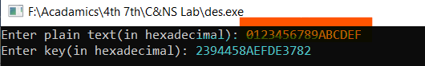

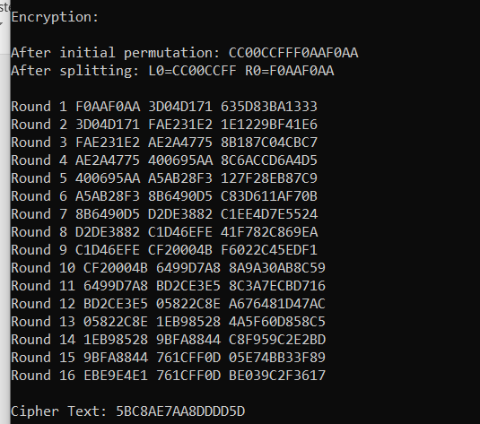

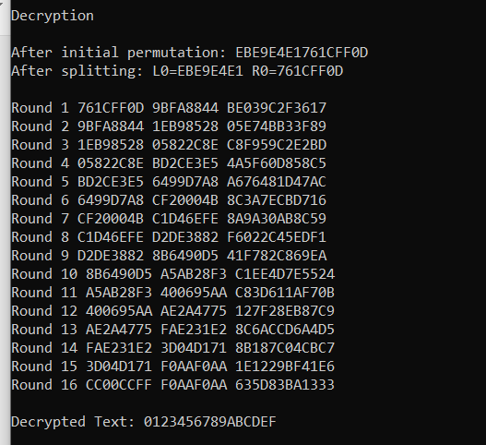

**Conclusion:**

The experiment is performed by writing a code for encryption & decryption and tested.